Irvine IOT – Course 2

Arduino Platform and C Programming

# **Module 1**

## Arduino Platform

IDE = Integrated Development Environment

Arduino Board  
Can receive analog input but it can’t give analog output

The microcontroller on the board that we are writing to is called the ATmega328 (It is that big long black thing)

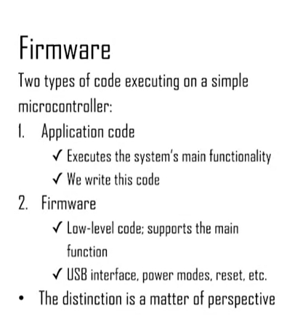

We do not write firmware code (firmware is what is already written in the Arduino

## Direct Programming

We will typically not need to do this. This is not the regular way to program and interact with the arduino. This we will only need to do in special circumstances

(I think this is called In-Circuit Serial Programming (ICSP)

The only time we’ll need to do this is to update the bootloader

## Arduino Schematics

## Arduino IDE

First some Basic Arduino Specs

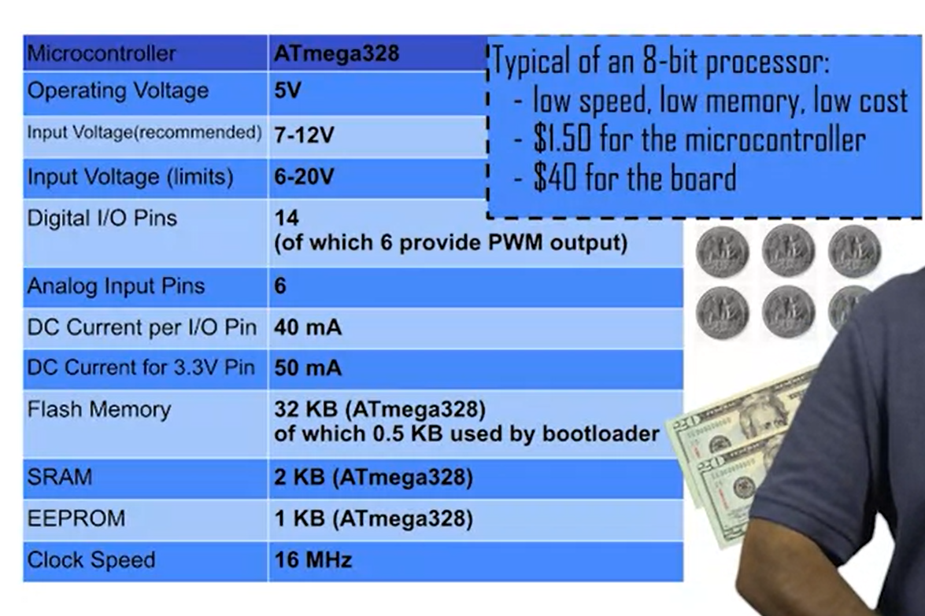

SRAM is gets erased when you restart the arduino

EEPROM is like flash

## Compiling Code

## Arduino Shields and Libraries

Just making the point that there are a lot of pre-written libraries

## Arduino Basic Setup